Blinkit Analysis

- SELECT * FROM blinkit_data
- Data Cleaning: Cleaning the Item_Fat_Content field ensures consistent and accurate data by standardizing similar values (e.g., LF, low fat, Low Fat). This improves data quality and makes analysis and reporting easier.
UPDATE blinkit_data
SET Item_Fat_Content =
CASE
WHEN Item_Fat_Content IN ('LF', 'low fat') THEN 'Low Fat'
WHEN Item_Fat_Content = 'reg' THEN 'Regular'
ELSE Item_Fat_Content
END;

After executing this query check the data has been cleaned or not using below quer
SELECT DISTINCT Item_Fat_Content FROM blinkit_data;
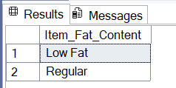

- KPI’s
- Total Sales:
SELECT CAST(SUM(Sales) / 1000000.0 AS DECIMAL(10,2)) AS Total_Sales_Million
FROM blinkit_data;
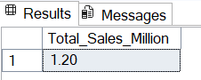

- Average Sales:
SELECT CAST(AVG(Sales) AS INT) AS Avg_Sales
FROM blinkit_data;
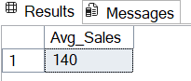
- No. of Items
SELECT COUNT(*) AS No_of_Orders
FROM blinkit_data;
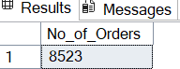
- Avg Rating
SELECT CAST(AVG(Rating) AS DECIMAL(10,1)) AS Avg_Rating
FROM blinkit_data;
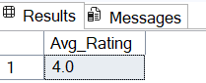
- Total Sales by Fat Content

SELECT Item_Fat_Content, CAST(SUM(Sales) AS DECIMAL(10,2)) AS Total_Sales
FROM blinkit_data
GROUP BY Item_Fat_Content
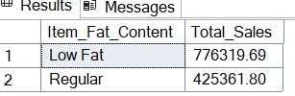
- Total Sales by Item Type
SELECT Item_Type, CAST(SUM(Sales) AS DECIMAL(10,2)) AS Total_Sales
FROM blinkit_data
GROUP BY Item_Type
ORDER BY Total_Sales DESC

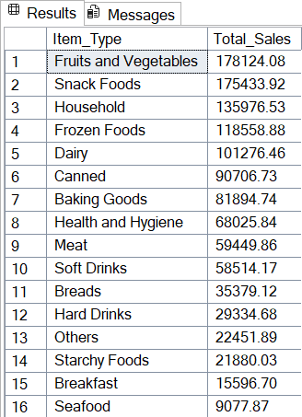

- Fat Content by Outlet for Total Salesq
SELECT Outlet_Location_Type,
ISNULL([Low Fat], 0) AS Low_Fat,
ISNULL([Regular], 0) AS Regular
FROM
(
SELECT Outlet_Location_Type, Item_Fat_Content,
CAST(SUM(Sales) AS DECIMAL(10,2)) AS Total_Sales
FROM blinkit_data
GROUP BY Outlet_Location_Type, Item_Fat_Content
) AS SourceTable
PIVOT
(
SUM(Total_Sales)
FOR Item_Fat_Content IN ([Low Fat], [Regular])
) AS PivotTable
ORDER BY Outlet_Location_Type;
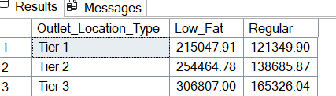

- Total Sales by Outlet Establishment

SELECT Outlet_Establishment_Year, CAST(SUM(Sales) AS DECIMAL(10,2)) AS Total_Sales
FROM blinkit_data
GROUP BY Outlet_Establishment_Year
ORDER BY Outlet_Establishment_Year
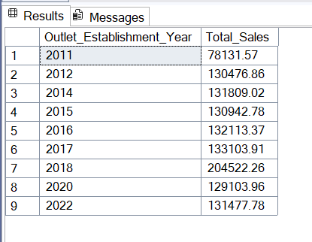
- Percentage of sales of Outlet Size
SELECT
Outlet_Size,
CAST(SUM(Sales) AS DECIMAL(10,2)) AS Total_Sales,
CAST((SUM(Sales) * 100.0 / SUM(SUM(Sales)) OVER()) AS DECIMAL(10,2)) AS Sales_Percentage
FROM blinkit_data
GROUP BY Outlet_Size
ORDER BY Total_Sales DESC;
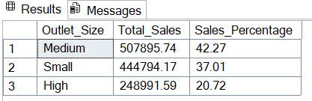
- Sales by Outlet Location
SELECT Outlet_Location_Type, CAST(SUM(Sales) AS DECIMAL(10,2)) AS Total_Sales
FROM blinkit_data
GROUP BY Outlet_Location_Type
ORDER BY Total_Sales DESC
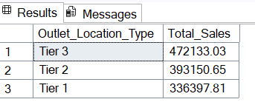

- All Metrices by Outlet Type
SELECT Outlet_Type,
CAST(SUM(Sales) AS DECIMAL(10,2)) AS Total_Sales,
CAST(AVG(Sales) AS DECIMAL(10,0)) AS Avg_Sales,
COUNT(*) AS No_Of_Items,
CAST(AVG(Rating) AS DECIMAL(10,2)) AS Avg_Rating,
CAST(AVG(Item_Visibility) AS DECIMAL(10,2)) AS Item_Visibility
FROM blinkit_data
GROUP BY Outlet_Type
ORDER BY Total_Sales DESC
